Bill of Lading

**International maritime transport of goods** is regulated by the 1978 Hamburg Rules, created by the UNCITRAL. In order to carry out said transport and according to the Hamburg Rules it is necessary to use documents that give knowledge about the operation, this document is called **"Bill of Lading (B/L)".**

The Bill of Lading is used in the maritime transport of goods under the Regular Line regime and fulfills the following functions:

* As receipt of the goods shipped on the ship and the state in which they are located.
* Prove the existence of a transportation contract.
* Ownership of the transported merchandise falls on the holder of the document, which will be the one that can pick up the merchandise at the port of destination.
* It is negotiable and admitted to banking entities as a credit instrument

Figures within the bill of lading or Bill of Lading:

* Shipper
* Carrier: Shipping or Shipowner
* Exporter
* Consignee: Recipient of the merchandise
* Notify: Person who will be notified of the arrival of the goods at destination

The Bill of Lading is issued by transport companies (shipping companies, ship owners or consignees) or by the captain of the ship. 3 to 5 original copies of the Bill of Lading are issued and can be made at the order of the shipper, at the order of the consignee, nominative or bearer.

**Standard Route of Bill of Lading or Bill of Lading since its issuance:**

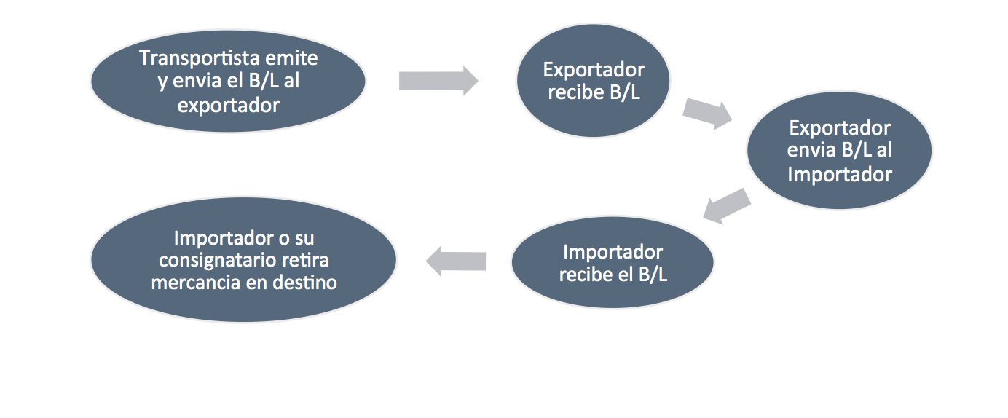

When the merchandise is received to be shipped in the acknowledgment of receipt, the status of the same must be indicated using the following options:

* **Clean On Board**: The Master of the ship recognizes that the goods have been received on board in "Perfect Condition and Apparent Conditions".
* **Dirty**: The captain of the vessel expresses reservations regarding the status and condition of the goods. It presents difficulties due to documentary credit.
* **Letters of Guarantee**: the shipper transfers to the shipowner any claim that can be made for the extension of clean knowledge when it is a "little dirty". They can cause fraud.
* **Thorugh**: When there are no scales between Port of loading and Port of discharge.
* **Combined**: When transferring cargo between loading port and unloading port. A single document and is transferred from one company to another until the merchandise reaches its destination.
* **Shipped On Board**: This is the bill of lading issued after the shipment of the goods on board the ship. If the real knowledge, assumes that the merchandise has been shipped and that it has left the port of origin.

Annotations in the Bill of Lading:

* **Said To Contain**: Applies to the shipment of goods stowed in complete FCL or incomplete LCL groupage containers. It indicates that the Captain has received a container and that it ignores its contents.
* **Ignoring weight and content**: The Captain has not verified the accuracy of the weight and / or content of the merchandise. With this expression, it is exempt from any responsibility, since the jetty provided the data of the Bill of Lading

The possession of the Bill of Lading and therefore the ownership of the merchandise can have the following implications:

* **Possibility of endorsing**: The document is endorsed to a third party to cover an outstanding payment, the third party will be the new possessor of the merchandise that can be sold once it is removed at destination. The B/L must have been issued "to order" so that it can be endorsable.
* **Possibility of negotiating**: Advances can be obtained from banking entities.
* **Possibility of pledging**: The importer can obtain a loan from his bank giving as collateral the goods reflected in the B/L.

This document must include the following minimum content to be valid:

* Name and address of the transporter.
* Name and Address of the Charger.
* Name and Nationality of the vessel.
* Port of Loading and Unloading or the final destination ("orders").
* Name and Address of the Recipient (registered). Of the person or entity to whom the arrival of the goods must be notified, if the knowledge is at the order of the shipper or an intermediate ship.
* The nature and quality of the merchandise, number of packages or pieces or quantity or weight and identifying marks.
* State and apparent condition of the load.
* FLETE agreed and place of payment. In case of being paid it will be written "pre-paid" otherwise "collect"
* Originals delivered.
* Place, date and signature of the transporter, maritime agent or Captain.

**The Sea Way Bill (SWB):**

It is very similar to the Bill of Lading but with the difference that it does not convey the ownership of the merchandise, it is a proof of a maritime trade operation.